**Finally Got In**

***Log Analysis***

**Challenge:**

Can you find the successful login attempt? Password is the flag.

Attached - web2.pcap

**Approach:**

That’s a wireshark capture file so we first open it up on wireshark.

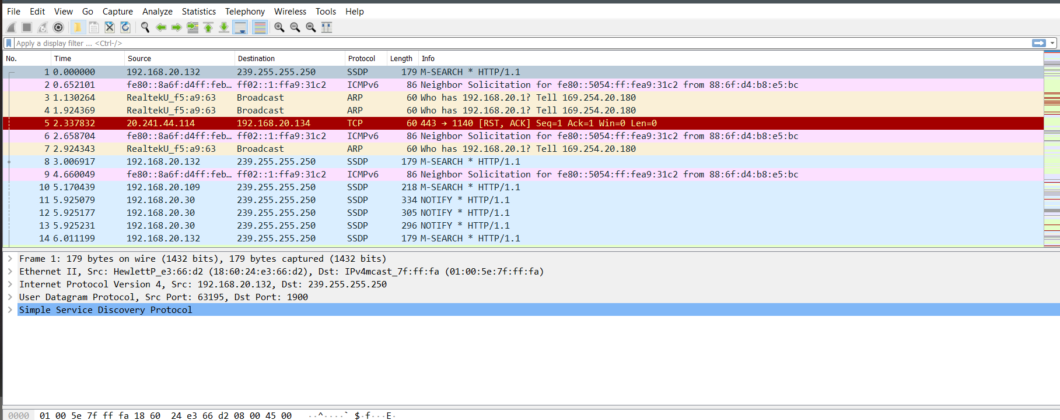

The challenge talks about login data being sent, we apply the display filter for HTTP and sort the ‘Info’ section to take a look on the packets with ‘POST’ headers only (Since login data would be in a POST request)

Right Click on any packet > Follow > TCP Stream and we see the response to that request as well. We iterated through the 5 packets until we found the one that successfully logs in the user.

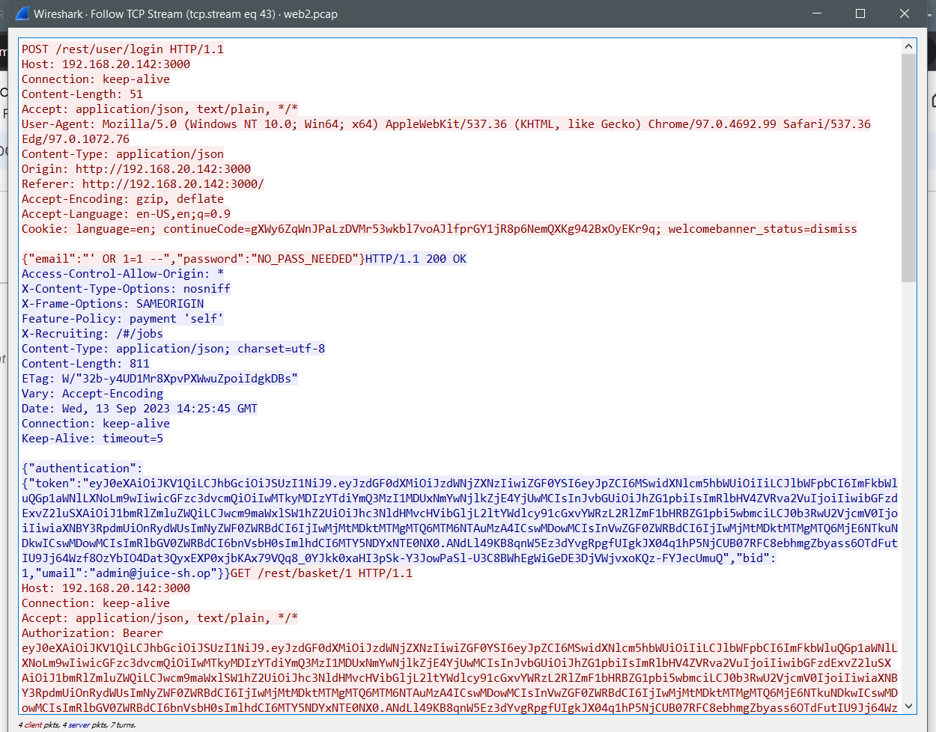

We see the password provided in the request and we get our flag!

**Flag: NO_PASS_NEEDED**

Congrats!!

Happy Hacking!